Resnet Evaluation with Augmentation

The content demonstrates some of the results from training, along with a table of evaluation results for resent 50 models trained using the current combined basic augmentations (random horizontal flipping, regional cropping, random gray scale, and random contrasting). The models where trained using the following fixed learning rates 0.0001, 0.0005, 0.001, and 0.005. The results from the training can be seen the table below. Note training the model with a Resnet34 backbone at a learning rate of 0.005 failed and thus the the results for this model are blank

LR | Resnet 50 |  |  |  | Resnet 34 |  |  |  | Resnet 18
LR | mAP | AP50 | AP75 | FPS | mAP | AP50 | AP75 | FPS | mAP | AP50 | AP75 | FPS
0.0001 | 0.500 | 0.815 | 0.556 | 11.101 | 0.520 | 0.828 | 0.603 | 12.278 | 0.500 | 0.795 | 0.560 | 13.499
0.0005 | 0.575 | 0.850 | 0.663 | 12.115 | 0.576 | 0.865 | 0.675 | 13.880 | 0.560 | 0.854 | 0.634 | 13.482
0.001 | 0.591 | 0.871 | 0.685 | 12.069 | 0.591 | 0.871 | 0.697 | 13.989 | 0.587 | 0.867 | 0.677 | 14.924
0.005 | 0.624 | 0.898 | 0.722 | 12.460 | --- | --- | --- | --- | 0.606 | 0.880 | 0.708 | 14.459

Resnet 50
0.0001 – 0.512 @ 142
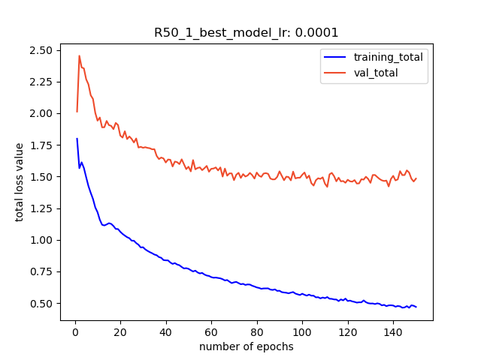

0.0005 - 0.572 @ 141
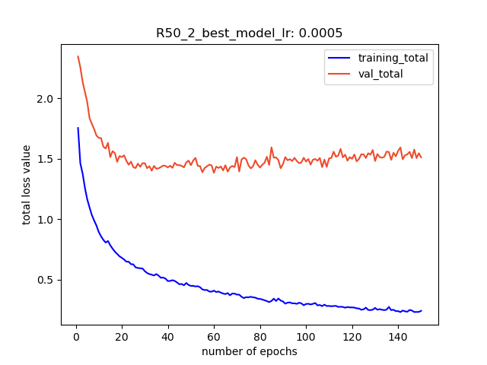

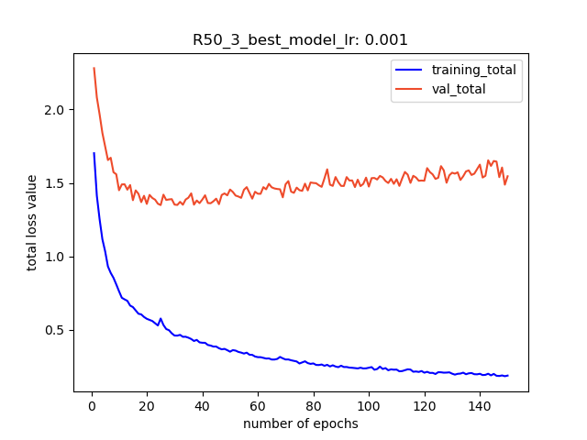
0.001 – 0.589 @ 129

0.005 - 0.625 @ 93
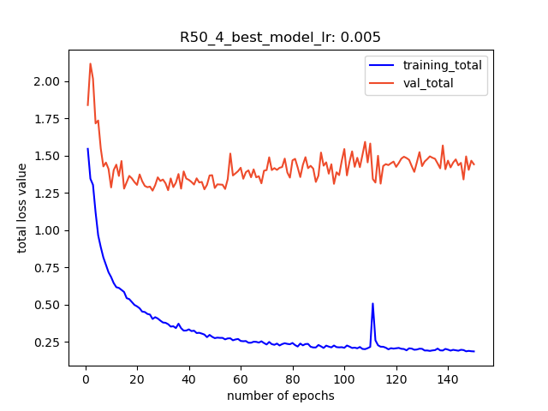

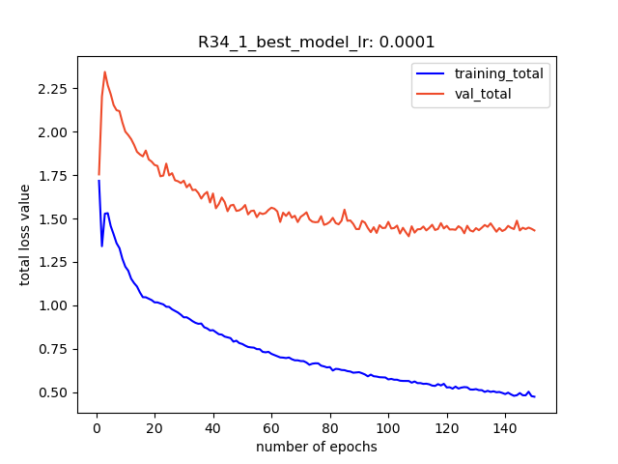
Resnet 34
0.0001 – 0.513 @ 136

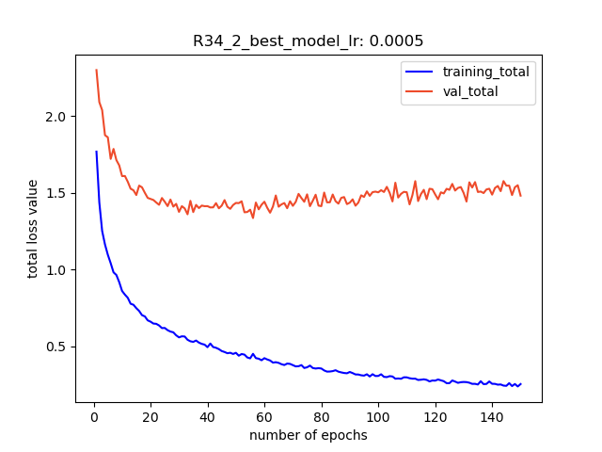
0.0005 – 0.561 @ 147

0.001 – 0.610 @
141
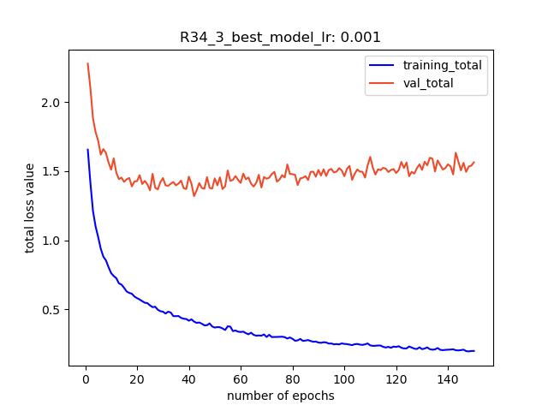

Resnet 18
0.0001 - best model 0.499 @ 148
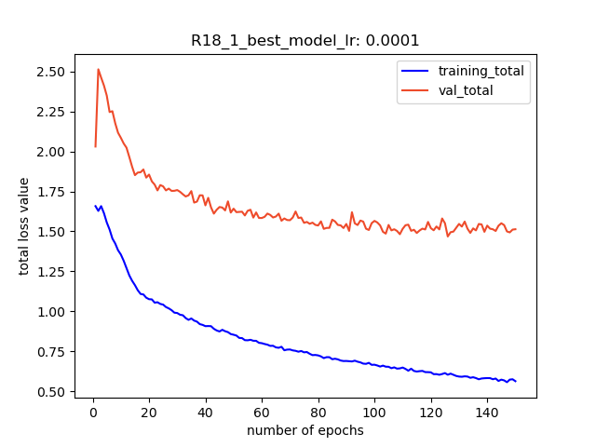

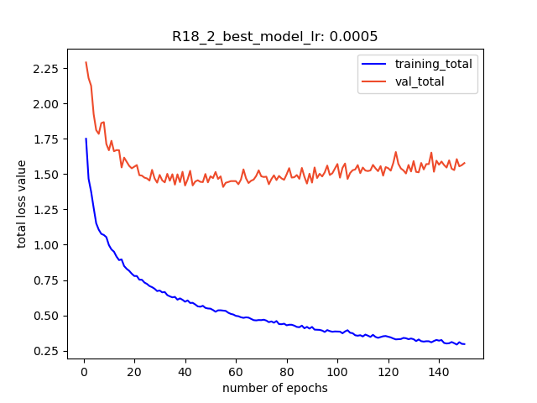
0.0005 - best model 0.569 @ 129

0.001– best model 0.586 @ 143

0.005 – 0.607 @ 89

